**CS202 Chapter 2 Homework**

Due: 9/11/17, 8AM Submitted: 9/6/17 Name: Manwai Nguyen Score:

P2.6

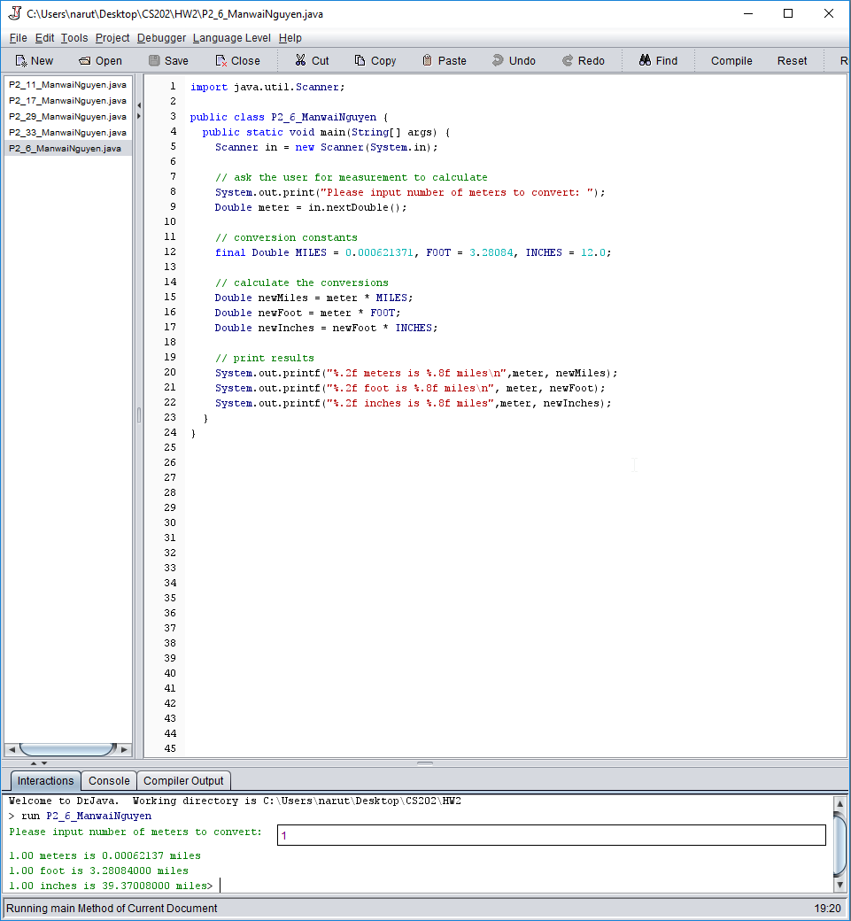

P2.11

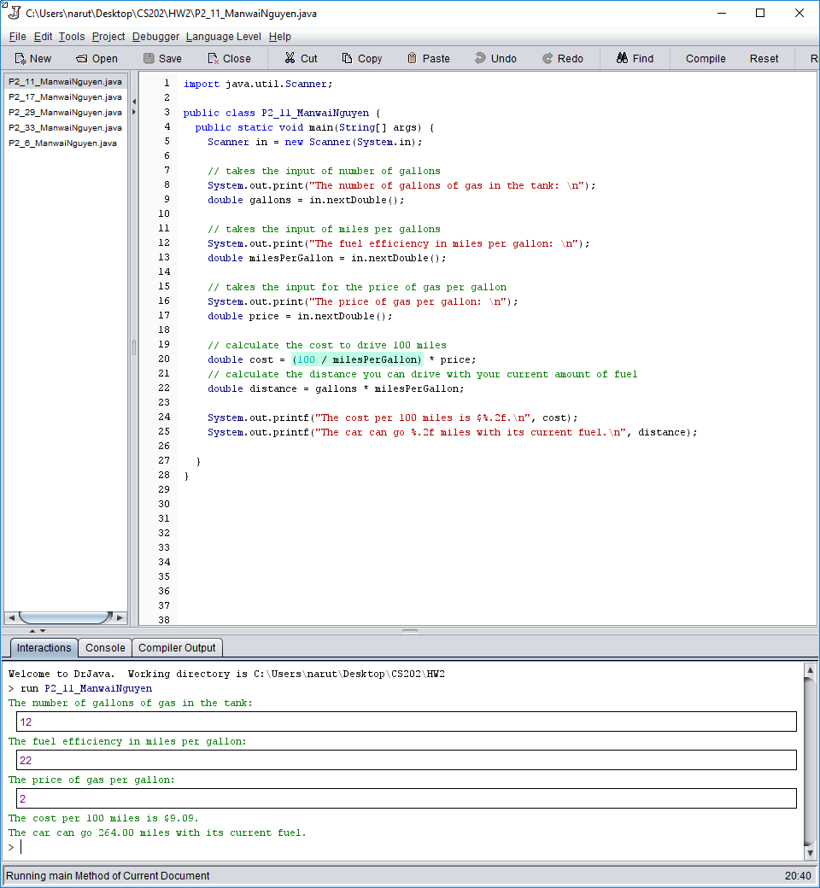

P2.17

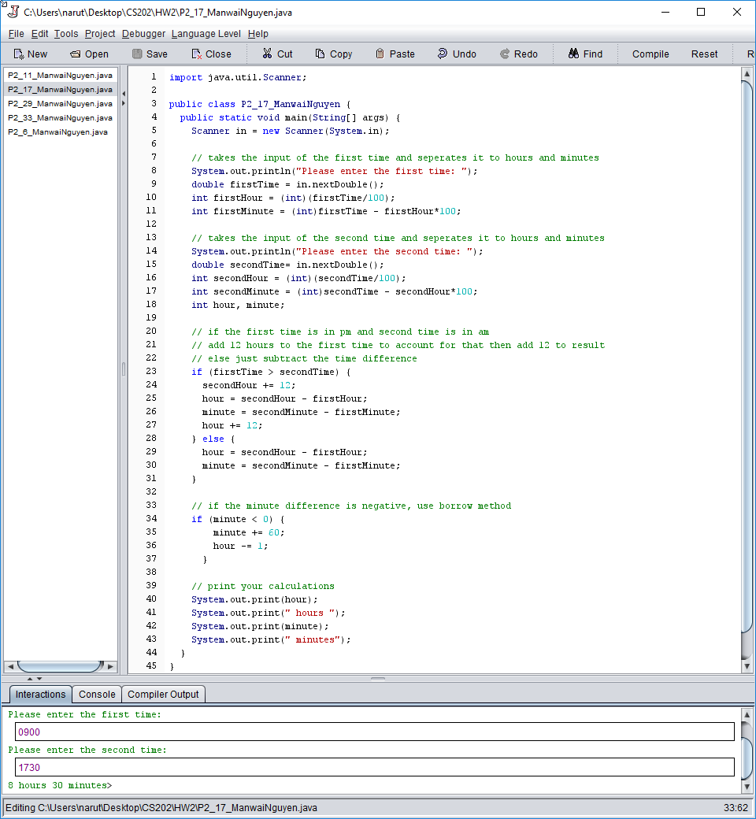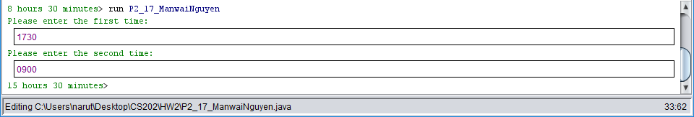

P2.29

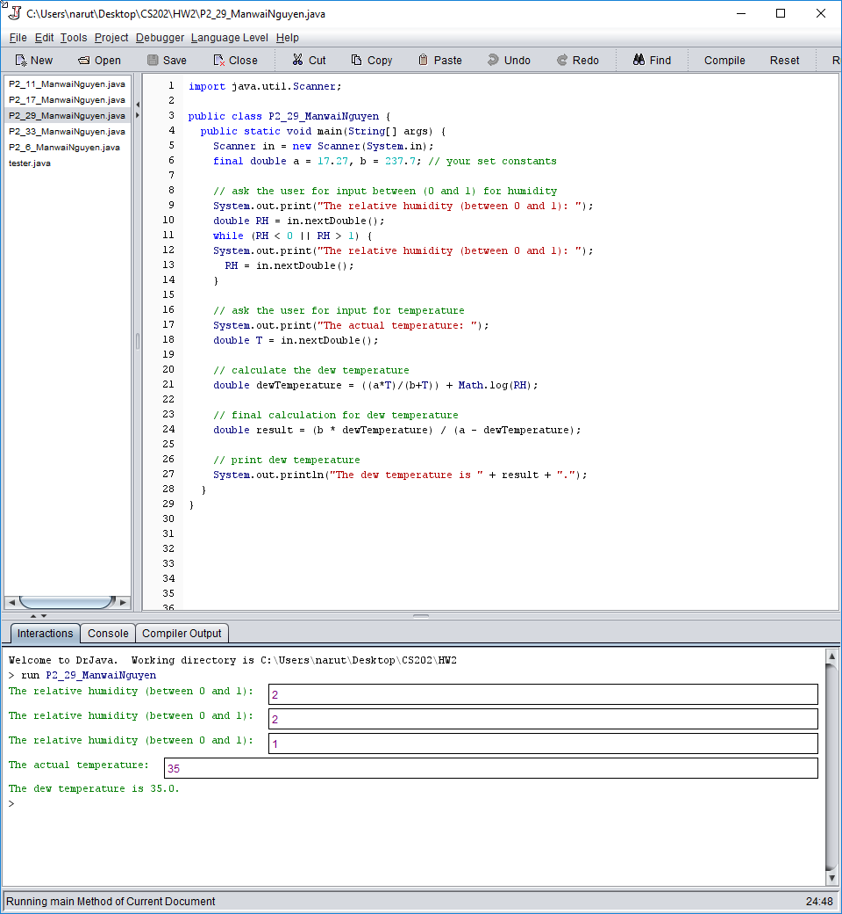

P2.33

